**Hello Thanks For Your Pantronage**

**Researchclue support team email address support@researchclue.com**

Please First Step is to extract the download software ..

Note: For Archive File

1. if it’s a zip compressed file please unzip the software( use winzip application or right click with a mouse and click extract all 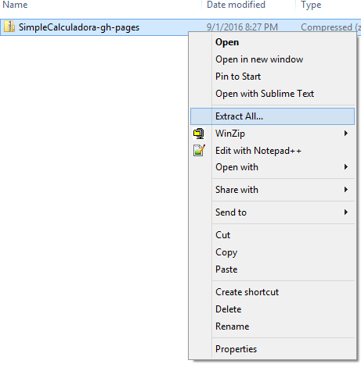
2. if its rar compress file please unrar the software

when you have the software the recommended server is WAMP server. I recommend you use our wamp. Cause its more reliable and covered both mysql and mysqli extension .

Links to download wamp from our server online.

<http://www.myresearchclue/softwares/wamp.exe>

once You have it on your system please follow these step below. Thanks

1. Install the application on you system. The installation process should take about 3 – 5 minutes
2. Once you are through with the installation please click to launch the package. NB: you will notice a symbol of this sought on you quick tool access point(by the date at your system task bar)

 or 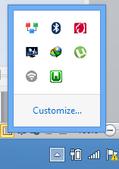 depending on you system

1. Next is you click on the GREEN ICON then a tray will pop-up ( see image below) 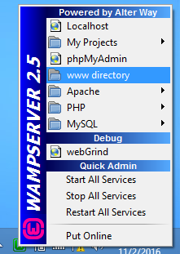 Click on the www directory
2. When you click the www directory window a file explore will open please copy the downloaded software you have extract. Copy it to that www directory folder.
3. You can manually access that folder by going following the path on your computer click my computer >local Disk (C: ) drive > wamp folder > www folder . there you are.. clap for yourself.

You Are 20 % Ready ………….Lets Roll

These phase is quite technical so please follow me step by step

1. Click the icon again on the system tray
2. Then click on phpMyAdmin 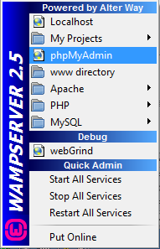
3. Then you will see a page like this below

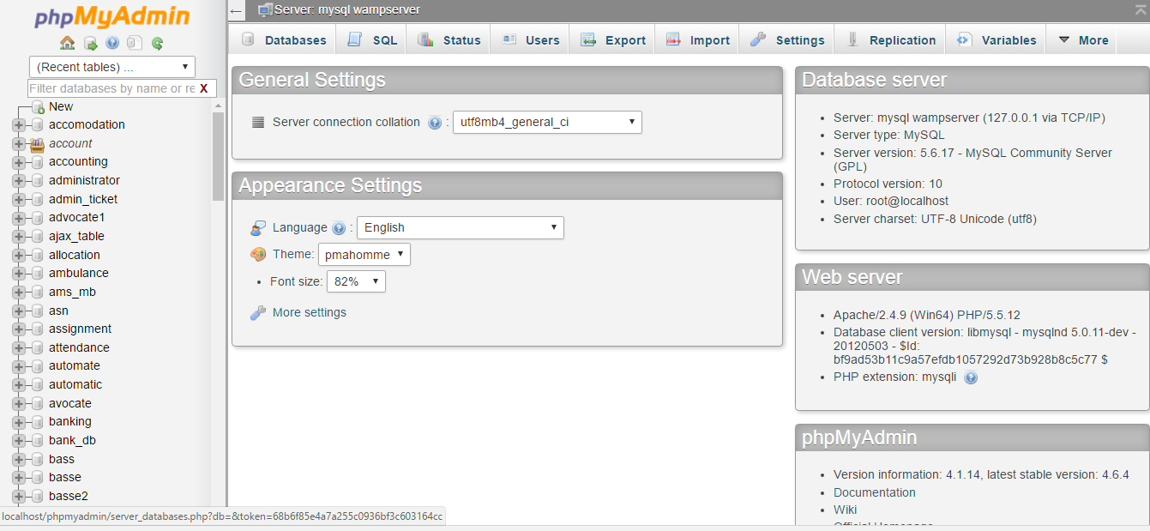

Congrats you are 22% ready

1. Please click on the menu above , click on Database 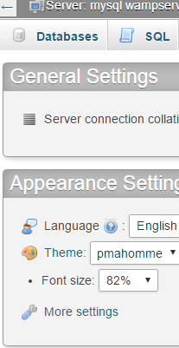 the a window like this will display before 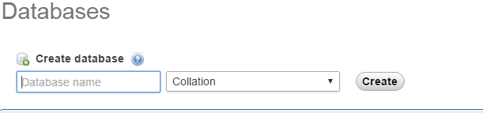 Please type the database name on that window and click create.
2. Am sure you will be asking me whats the name of the database, yes please check the folder you will see a folder called ‘database’ or ‘db’ . if they is no folder as such don’t be scared. They should be a file in the folder with sql extention. See pic below.  not the SQL file thename of that file is the name of the database. Thanks take a deep breath now and repeat step 4.
3. After creating the database you will click on the database . see pic below(lets say am creating database accommodation after creating you will click below …like this ) 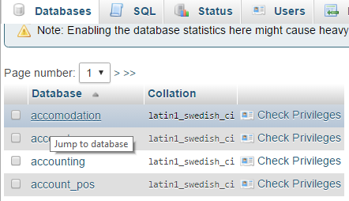
4. Next is to click on the SQL above 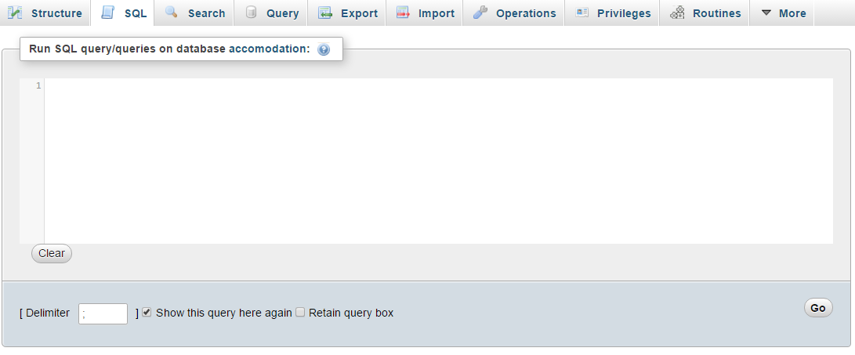
5. Note this step very well. Open the SQL file with notepad(the file with SQL extension)  select everything in it, copy and paste it in the sql window showing at Step 7 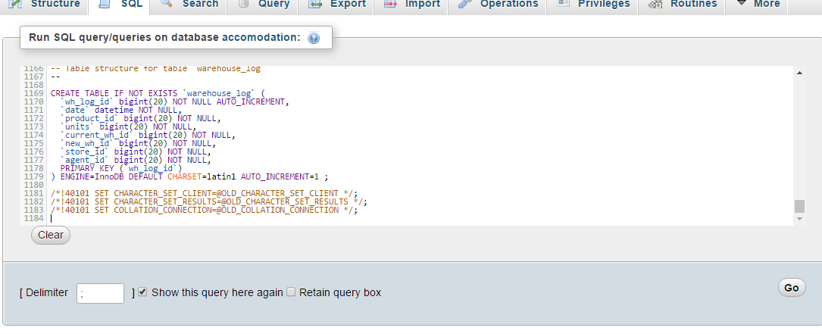. Next is to click the GO botton below 

At the Point you have succefully created a database for you project. Congrat!!

50% ready

1. Final Phase is to click on the wamp icon  on the tray again and click on localhost 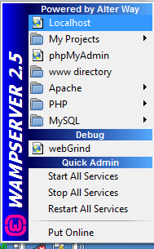

It will open your browser with a window exactly like mine below.. 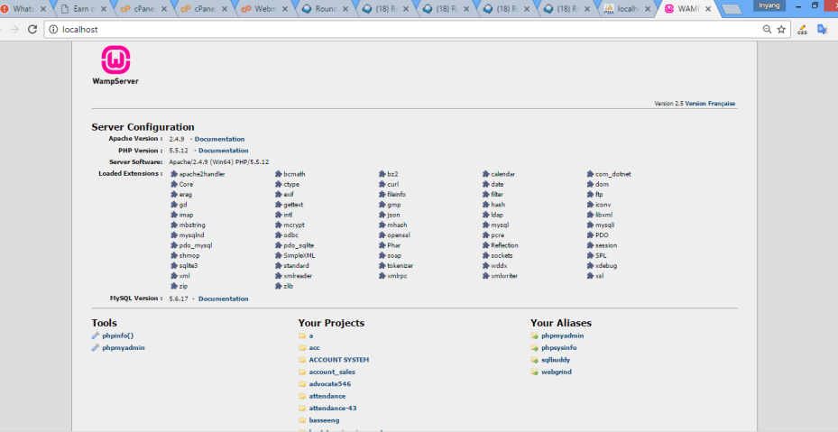

You should be able to see you project below on the “Your Projects” section 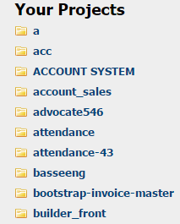

1. Final phase is to click on the your project or type your project name on the URL with this extension i.e let my access the accommodation project http://localhost/ accommodation / then click the enter button

Congrats You project is ready to Go.

These are Username and password to our systems . one of these should grant you access to the system. Thanks

Username: a. admin b: [admin@admin.com](mailto:admin@admin.com) c: [admin@example.com](mailto:admin@example.com)

Password: a. admin b: admin123 c: admin12345